***DAY 1 : M.L. :***

In today’s world when we talk about technology these huge words like Artificial Intelligence (A.I.), Machine Learning (M.L.), Deep Learning (D.L.), etc. are always heard. In this blog, I am going to explain an overview on these topics and talk in depth about a particular topic of ***MACHINE LEARNING***.

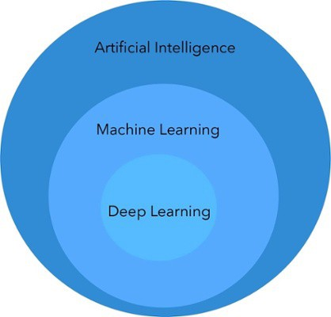In words of one syllable, A.I. could be explained as big bubble of conceptional technology with M.L. & D.L. as it’s two components. This is explained by the image below:

**A.I**.- It is simply explained as mimicking a human intelligence by a machine, which is able to perform human alike tasks.

**M.L.-** This simply could be explained as a subset of A.I., which learns from the user experience and tries to implement the same.

**D.L.-** This is a subset of M.L., which is used to perform more complex tasks such as classifying images, audios & videos.  
*\*image source: TOWARDS DATA SCIENCE.*

MACHINE LEARNING:

This topic has been heard a lot in the recent years, this concept of machine learning can be explained as where machines learn from human experience and tries to implement the same or maybe better. This could be better explained in an example by Arthur Samuel(computer scientist at Stanford), he basically trained a machine to play checkers, initially Arthur Samuel played with the computer where the machine basically taught itself how to play by recording Arthur’s experience , over the time the machine got smarter and played better checkers than Arthur himself. As a machine can compute a large number of possibilities it was easy for the machine to see various outcomes in various game unlike any other human.

**CATEGORIES OF MACHINE LEARNING:**

Machine Learning is broadly divided into three categories which are *supervised, unsupervised & reinforcement learning.*

The above three topics are explained as follows:

1. SUPERVISED LEARNING: As the name suggests, it involves a supervisor who is more knowledgeable than the neural network or the machine and knows the output for few problems.

The supervisor then gives these problem (whose answers are known) as input to the machine which is called as the training set to make understand the machine on what the supervisor is trying to achieve or predict.

Supervised learning is divided into 2 more categories:

* REGRESSION: this type of method mostly has huge and continuous data input for which we have to find or predict the output for example weather forecast, housing price predictions, etc. where the input values keep changing. For instance, nowadays we can predict about when we might reach the covid-19 peak.
* CLASSIFICATION: the model can be explained with examples like predicting whether one would win a game of PUBG or not considering the performances in the previous games. Also, spam detection is a classification problem whether a mail is a spam or not.

1. UNSUPERVISED LEARNING: this is unlike supervised learning, this neither has supervisor nor any examples whose outputs are already known. This is helpful in cases where one don’t have any clue in solving the problem. Here the machine has to understand the problem on its own for the data we provide to it.

Unsupervised learning is also divided into 2 more categories:

* CLUSTERING: this is the problem where we make groups of similar categories for example consider a newspaper it has different type of news displayed categorically like sports, business, political affairs, etc. which are further classified too, for instance, sports into different ones like soccer, cricket, etc.
* ASSOCIATION: this can be explained as, if a customer prefers/buys A type of product is most likely to they might buy B type too. Here we are trying to find relations between two or more products or services that are preferred by people at the same time, for instance, when people buy notebooks they are most likely to buy pens, also when painters buys a canvas it is most likely he/she might buy brushes or paints too. Sometime the combination might be vague or weird to see but it actually is useful data. Many shopping malls would use this, so that they can place these products besides.

1. REINFORCEMENT LEARNING: this category is like teaching some new born kid to do some simple tasks like walking or holding things. This is different from supervised learning as there is a training set i.e. there are specific inputs for which we know the answer to, but here it basically learns from its experience repetitively, such as the example of Arthur playing checkers in the beginning, where the machine was learning from its experience which then resulted into a better checkers player than Arthur himself. ***ALPHA GO*** which is outsmarts people in playing video games.

**APPLICATION AND FRAMEWORKS OF MACHINE LEARNING:**

* Image detection which includes face detection and image classification.
* Speech recognition where speech is converted into text or also can be classified into categories.
* Prediction: here we can predict prices about housing, etc. as mentioned above.
* Few of the famous frameworks are: TensorFlow, Google Cloud ML Engine, sci-kit learn, PyTorch,etc.